user_id

username

password

survey_id

survey_name

survey_description

question_id

question_name

question_description

answer_id

answer_name

answer_description

|  |  |  |  |
| --- | --- | --- | --- |
| **Users**  user_id  username  password | **Surveys**  survey_id  survey_name  survey_description | **Questions**  survey_id  question_id  question_name  question_description | **Answers**  user_id  survey_id  question_id  answer_id  answer_name  answer_description |

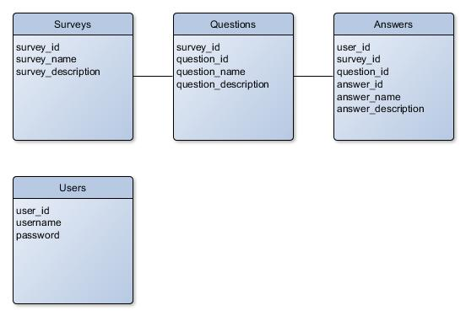

**Extra table aanmaken met een user_id, question_id & answer_id**